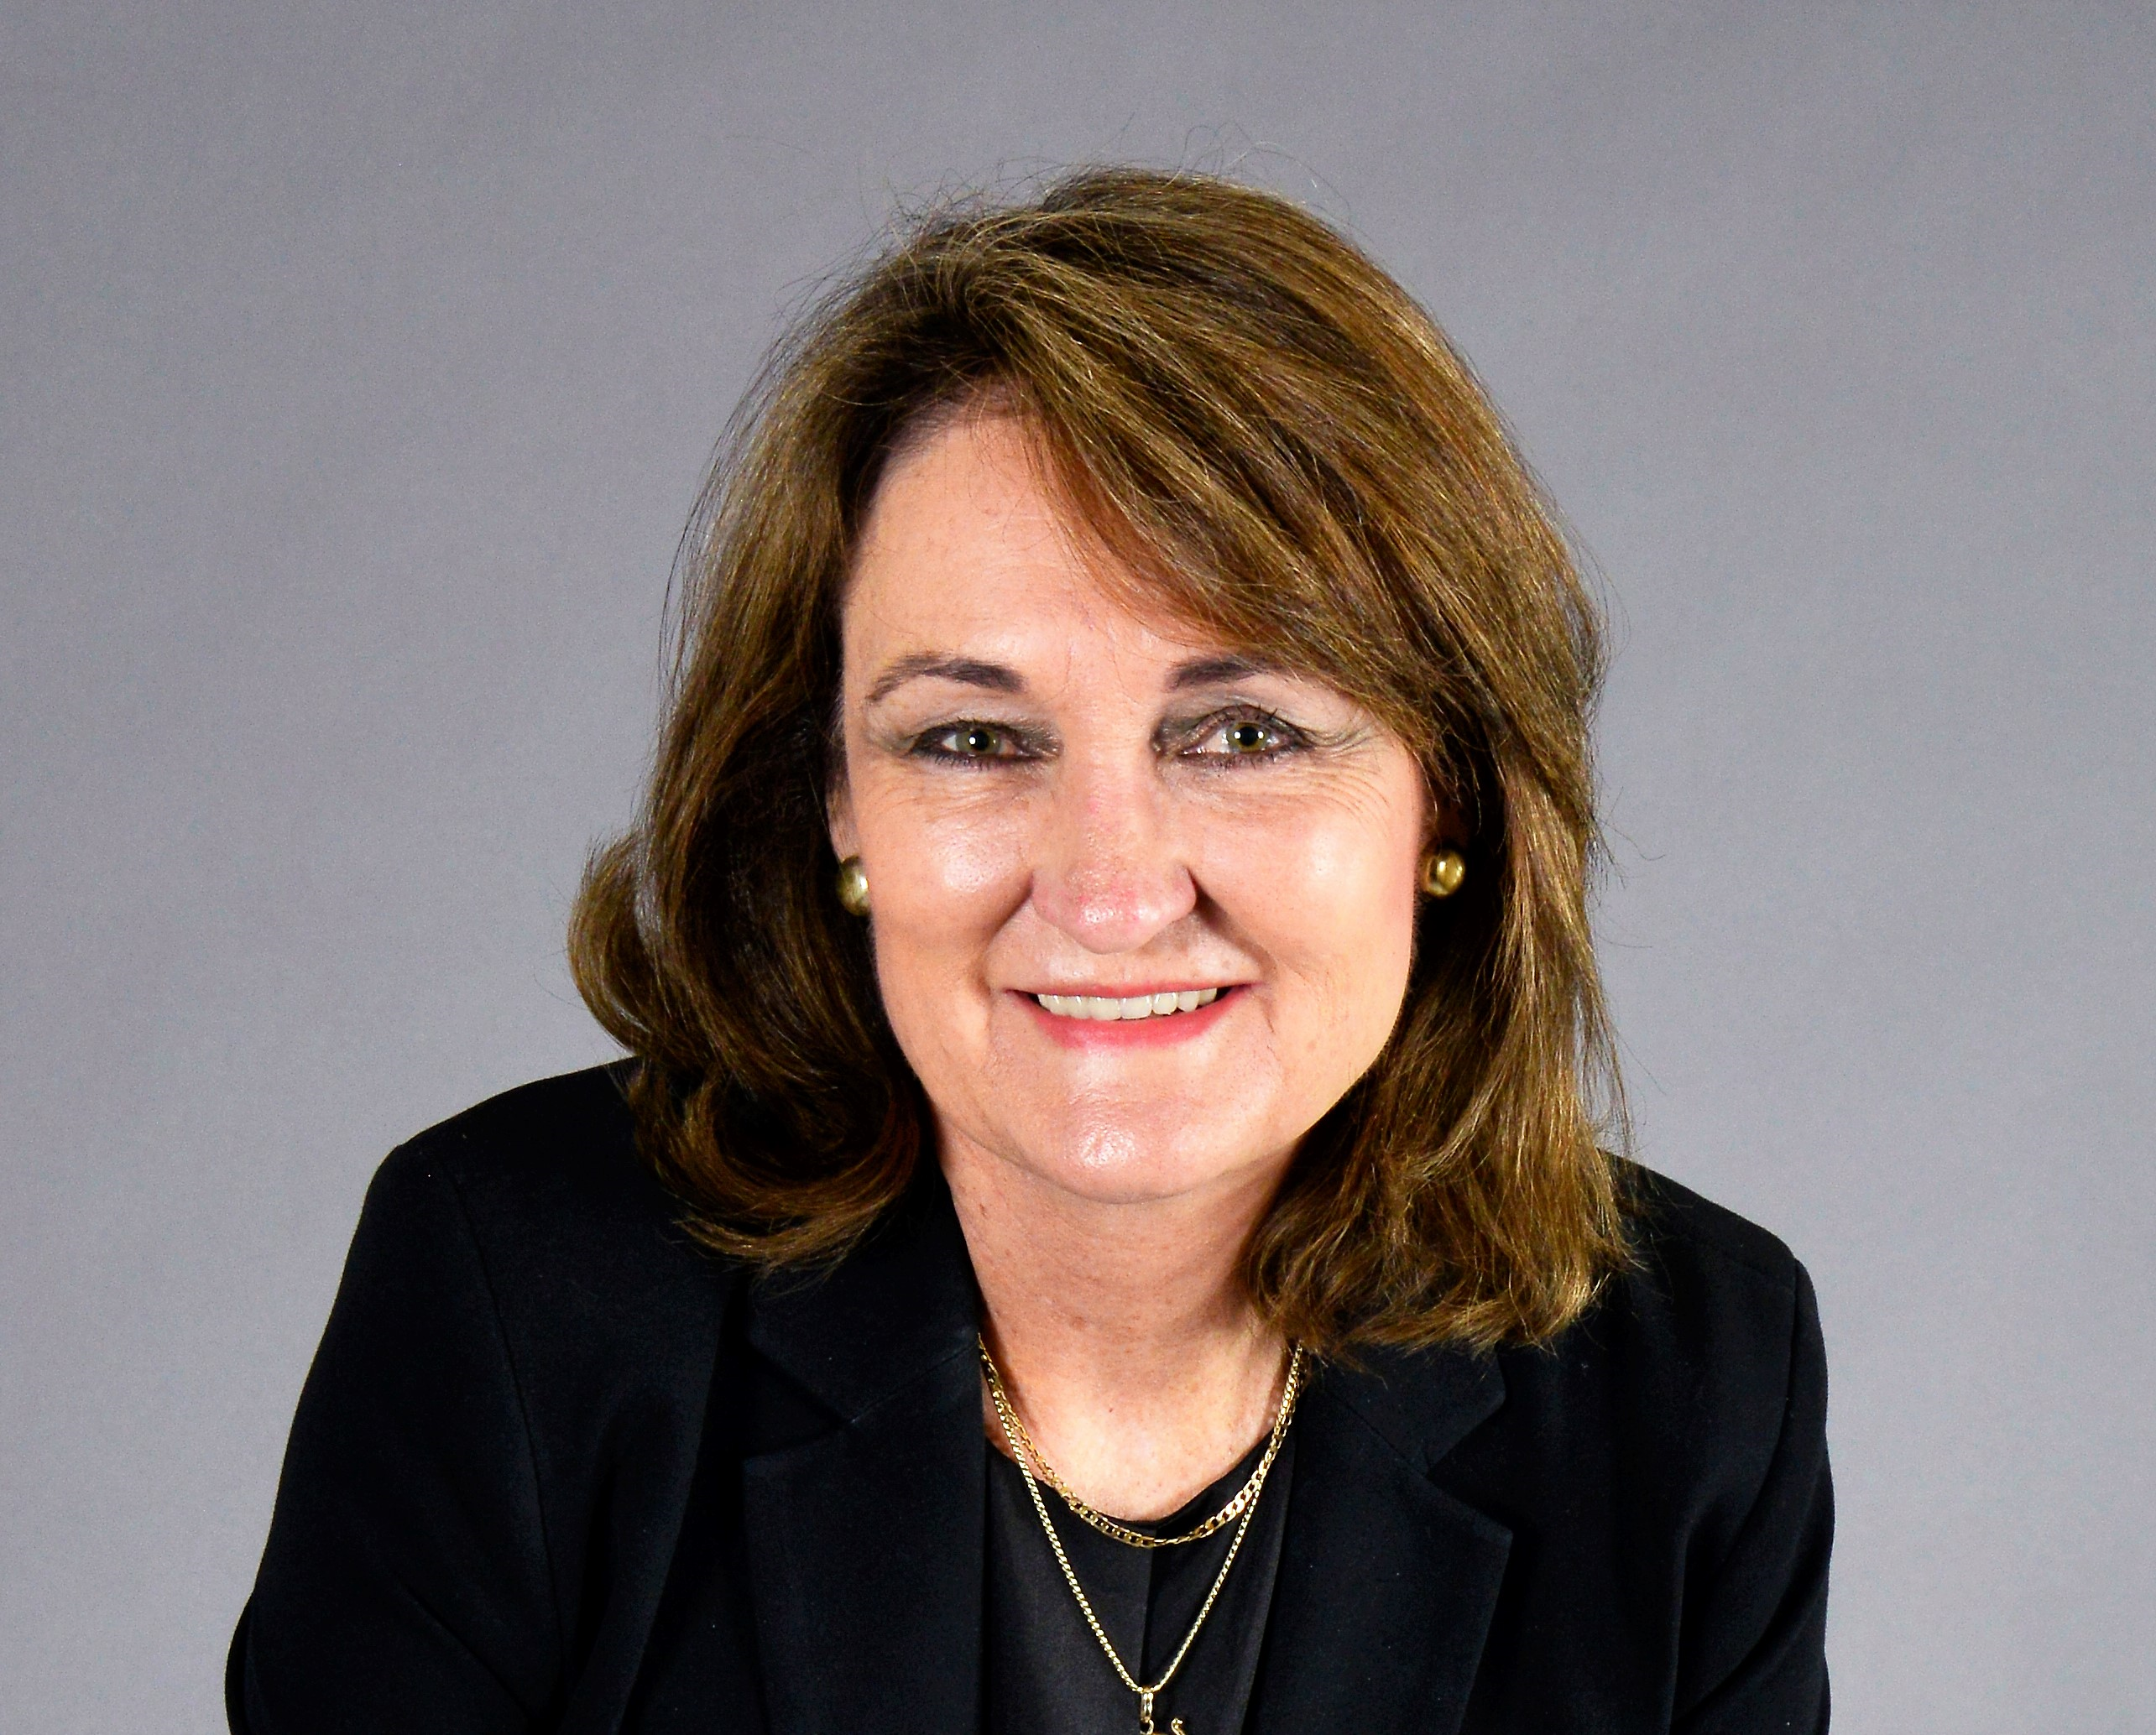
Professor Petro Terblanche
Managing Director: Afrigen Biologics
Professor Petro Terblanche has a successful track record in the strategic and operational management of technology intensive organizations. She has played a key part in the design and implementation of South Africa’s biotechnology strategy. She is currently the Managing Director of Afrigen Biologics (Pty)Ltd based in Cape Town, South Africa. Afrigen hosts the global mRNA technology vaccine Hub under the COVAX initiative. Petro also holds a part time position as Professor in the Faculty of Health Sciences at the North-West University. Previously she held the position of Managing Director at Pelchem SOC Ltd. A considerable part of her career was in research and development at the South African Medical Research Council (SAMRC) as well as the Council for Scientific and Industrial Research (CSIR). She has several qualifications which include: a Master of Science in Medical Oncology and Cancer Biology (Cum Laude) from the University of Pretoria, a Doctorate in Oncology and Cancer Biology also from the University of Pretoria, post-doctoral she was a visiting scientist at Harvard University School of Public Health and thereafter, completing Management of Technology program at Massachusetts Institute of Technology. Prof Terblanche is the author of more than 200 scientific publications and conference papers in public health. She was recently acknowledged as one of the legends of science by the Academy of Sciences South Africa.

